

Windows Workflow Foundation

Hands-On Lab

Lab Manual
Lab 02 – Creating Custom Activities in Visual Basic 2005

Converted from C# to Visual Basic.NET courtesy of:
Microsoft MVP Ken Kam Hung Lin.
Information in this document, including URL and other Internet Web site references, is subject to change without notice. This document supports a preliminary release of software that may be changed substantially prior to final commercial release, and is the proprietary information of Microsoft Corporation.

This document is for informational purposes only. MICROSOFT MAKES NO WARRANTIES, EITHER EXPRESS OR IMPLIED, AS TO THE INFORMATION IN THIS DOCUMENT.

The entire risk of the use or the results from the use of this document remains with the user. Complying with all applicable copyright laws is the responsibility of the user. Without limiting the rights under copyright, no part of this document may be reproduced, stored in or introduced into a retrieval system, or transmitted in any form or by any means (electronic, mechanical, photocopying, recording, or otherwise), or for any purpose, without the express written permission of Microsoft Corporation.

Microsoft may have patents, patent applications, trademarks, copyrights, or other intellectual property rights covering subject matter in this document. Except as expressly provided in any written license agreement from Microsoft, the furnishing of this document does not give you any license to these patents, trademarks, copyrights, or other intellectual property.

Unless otherwise noted, the example companies, organizations, products, domain names, e-mail addresses, logos, people, places and events depicted herein are fictitious, and no association with any real company, organization, product, domain name, email address, logo, person, place or event is intended or should be inferred.

© 2007 Microsoft Corporation. All rights reserved.

Microsoft, MS-DOS, Windows, Windows NT, Windows Server, Visual Basic 2005 and Visual Studio are either registered trademarks or trademarks of Microsoft Corporation in the United States and/or other countries.

The names of actual companies and products mentioned herein may be the trademarks of their respective owners.

Contents
Lab 02: Creating Custom Activities 1
Lab Objective 1
Exercise 1 – Creating a Composite Activity Using the Activity Designer 1
Task 1 – Create a new Workflow Project 1
Task 2 – Creating an Activity Project 4
Task 3 – Building the Workflow Solution 7
Exercise 2 – Creating a Basic Activity 10
Task 1 – Creating a Workflow Project 10
Task 2 – Creating an Activity Project 10
Task 3 – Building the Workflow Solution 16
Task 4 – Adding an Executor Component 17
Task 5 – Building the Project 18
Task 6 – Updating the Activity to Send Email 18
Exercise 3 – Adding Validation to Check E-Mail Parameters 21
Task 1 – Adding an Email Validation Code Activity 21
Task 2 – Testing The Validator 24
Exercise 4 – Adding an Activity Designer 26
Task 1 – Add the Activity Designer 26
Task 2 – Testing the Activity Designer 28
Lab Summary 30

Lab 02: Creating Custom Activities
Activities are the unit of execution, re-use and composition of workflow models. Basic activities are steps within a workflow and composite activities can contain other activities. A base activity library comes with Windows Workflow Foundation and these activities can be used by dragging from the Visual Studio 2005 toolbox. Software developers can create their own activities which also appear in the Visual Studio 2005 toolbox and have the same fidelity as the activities in the base activity library.

Activities are classes and you can define properties, methods and events which can be referenced from the workflow that the activity is used within. You can build an activity or multiple activities into a .NET assembly and deploy them as re-usable libraries.

Estimated time to complete this lab: 60 minutes
The project files for this lab are in the c:\Windows Workflow Foundation\Labs\VB\Lab02 folder.

Lab Objective
The objective of this lab is to demonstrate how to create custom activities in Windows Workflow Foundation. You will also learn how to expose properties on an activity in a workflow and access the property values at runtime. The lab consists of four exercises. In the first exercise, you will create a composite activity using Visual Studio’s built-in activity designer. Next you create a basic activity that we will use to send email. Then you will add a validation component to the workflow to validate the e-mail parameters. Finally you will learn how to add a custom activity designer to your basic activity to provide a customized interface.

Exercise 1 – Creating a Composite Activity Using the Activity Designer
In this exercise, you will create an activity that consists of two separate code activities. You will use the resulting composite activity in a workflow project, running the project to see the output produced by the code activities.

Task 1 – Create a new Workflow Project
Workflow projects require a host to execute the workflow. For this exercise, you will create a console application to host and interact with your workflow process.
- Navigate to Start | All Programs | Microsoft Visual Studio 2005 | Microsoft Visual Studio 2005.
- Select the File | New | Project menu command.
- Visual Studio displays the New Project dialog box.
- Select the Visual Basic | Workflow project type.
- Select the Sequential Workflow Console Application template.
- Enter the path C:\Windows Workflow Foundation\Labs\VB\Lab02 in the Location field.
- Enter the name CompositeActivitySample in the Name field.

Name: CompositeActivitySample.

Path: C:\Windows Workflow Foundation\Labs\VB\Lab02.

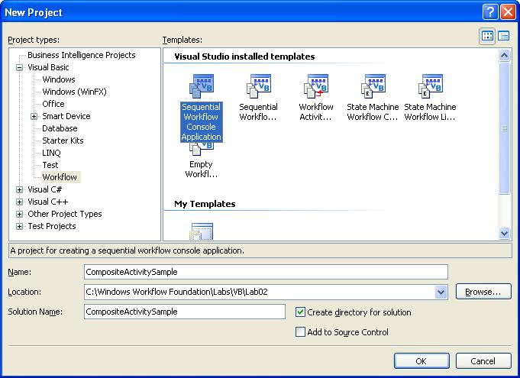

- Click OK.
- Visual Studio creates a Workflow console application and opens the Visual Studio workflow designer displaying a graphical representation of the workflow.

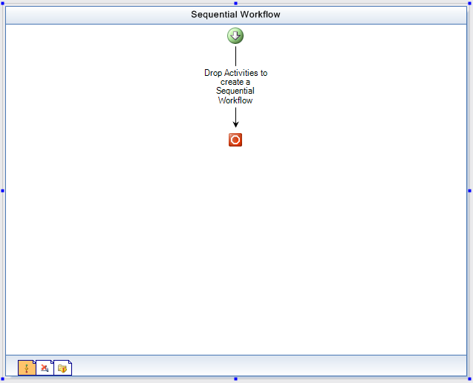

- In the Solution Explorer, right click on Module1.vb select View Code.
- Visual Studio displays Module1.vb in the main window.
- Module1.vb contains the Main() method for your workflow application. It contains boilerplate code to start the workflow runtime, load and execute the workflow, and then wait for the workflow to complete.
- In the Solution Explorer, right-click on Workflow1.vb and rename it to HelloWorldWorkflow.vb.
- If the Visual Studio displays the following dialog, click “Yes”.

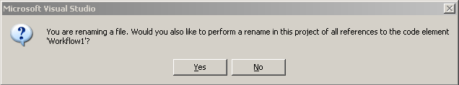

Task 2 – Creating an Activity Project
Now that you have created a Workflow project, the next step is to add an activity project to the solution. Once you have created the activity project, you will add two code activities to the activity project. The code activities will execute one after another to demonstrate sequential execution of business process elements. At a very high level, it can be said that there are two types of activities:
- Basic
- Composite
In other words, new activities can be defined either by creating new basic activities where they are implemented from scratch or, they can be composed of other existing activities as composite activities. The activity we will be creating in this exercise will be composing of two code activities, so it falls into the category of “composite” activities.

- Select the File | New | Project menu command.
- Visual Studio displays the New Project dialog box.
- Select the Visual Basic | Workflow project type.
- Select the Workflow Activity Library template.
- Rename the default project name, ActivityLibrary1 to HelloWorldActivityLibrary.
- Select Add to Solution from the Solution dropdown list.

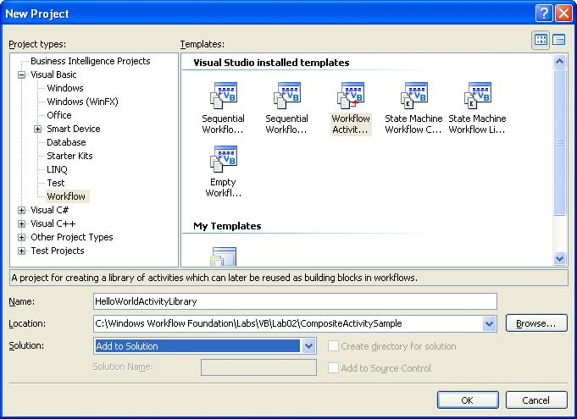

- Click OK.
- Visual Studio creates the activity library project, including a single activity, Activity1, and displays a design view of Activity1.vb.
- Rename Activity1.vb to HelloWorldActivity.vb by right clicking on Activity1.vb and choosing rename.
- If the Visual Studio displays the following dialog, click “Yes”

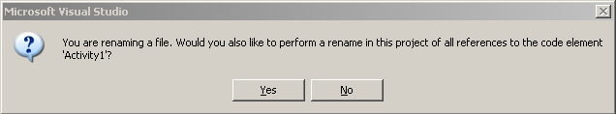

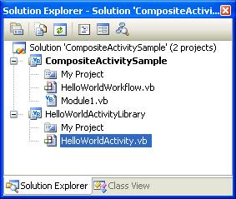

- Your designer should now have HelloWorldActivity loaded, if not double click on HelloWorldActivity.vb in the Solution Explorer.

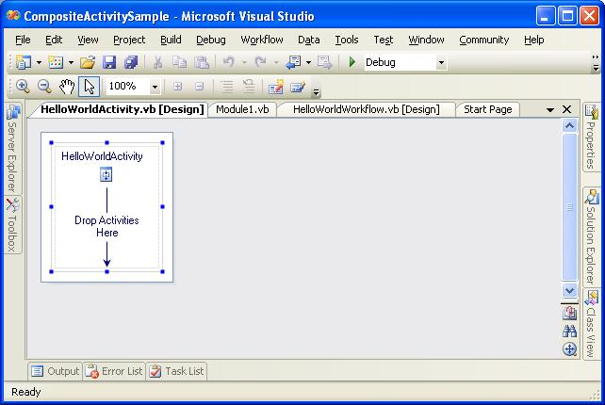

- Click on the HelloWorldActivity icon or surrounding work area to view the properties for HelloWorldActivity in the Properties window.

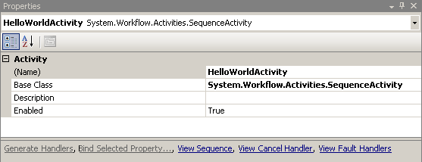

- Select the View | Toolbox menu command to open the Toolbox window.

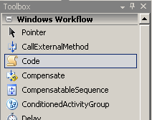

- From the Toolbox window, drag a Code activity and drop it onto the “Drop Activities Here” work area of HelloWorldActivity ‘s design view.
- The Activity Designer displays a code icon in the work area.

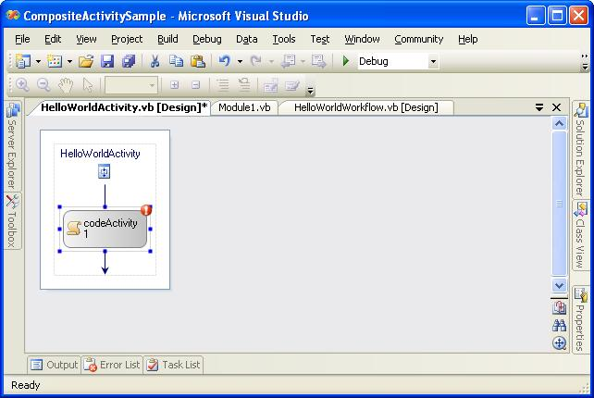

- Change the (Name) property of the code activity to writeHello.

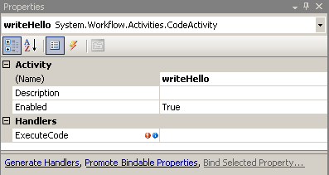

- Double click the writeHello activity to view the writeHello_ExecuteCode method.
- Paste the following code in the writeHello_ExecuteCode method body.
Console.Write("Hello, ")
- Double click HelloWorldActivity.vb in the Solution Explorer to return to the Visual Studio workflow designer.
- Drag a second Code activity onto the design area below the first code activity and change the (Name) property to writeWorld.
- Double click the Code icon you just placed onto the design area to open the code view of the writeWorld _ExecuteCode method.
- Type the following code in the writeWorld _ExecuteCode method body.
Console.Write("World")
- The code for the HelloWorldActivity class should now look like this:

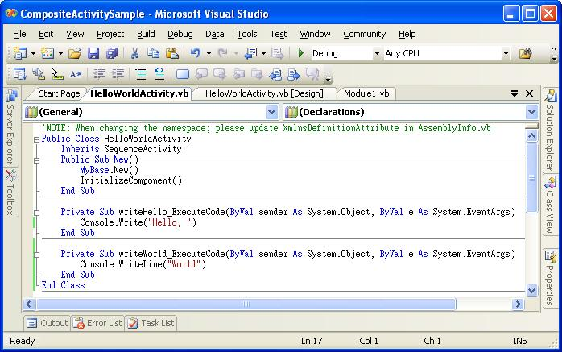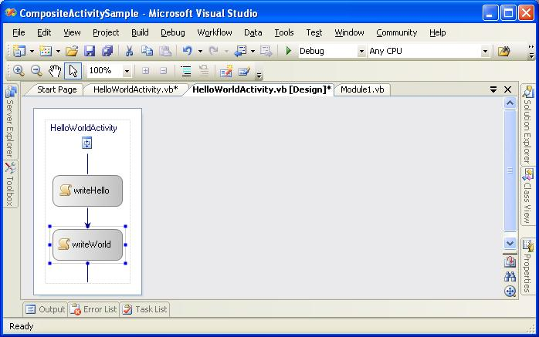

Task 3 – Building the Workflow Solution
You will now add the newly created activity to the Workflow and run the solution.

- Select the Build | Build Solution menu command.
- In the Solution Explorer, double click on HelloWorldWorkflow.vb to switch to the Design view of the Workflow.
- Notice that there is a new entry in the Toolbox list, HelloWorldActivityLibrary Components, under which the activity created in the last Task, HelloWorldActivity, appears.

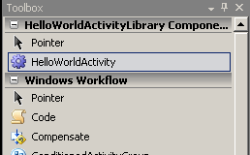

- Drag HelloWorldActivity onto the Visual Studio workflow designer and drop it onto the area labelled “Drop Activities to create Sequential Workflow”. Change the (Name) property of the activity to helloWorld.
- The Visual Studio workflow designer updates the display to include HelloWorldActivity, including the two code activities, as follows:
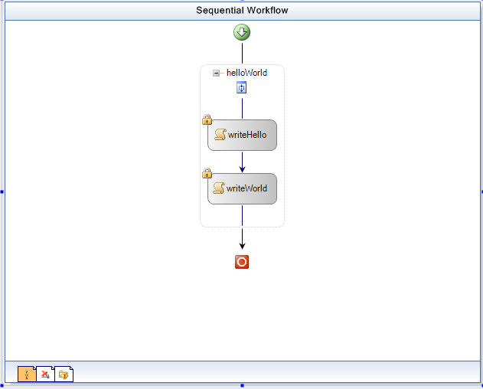

- Select the Build | Build Solution menu command.
- Select the Debug | Start Without Debugging menu command to run the program and see the following output in the console.

- Press the Enter key to end the program.
- Select File | Save All.
- Select File | Close Solution.

Exercise 2 – Creating a Basic Activity

In this exercise, you will create another Workflow project that contains an activity with custom properties. You will use the custom properties to specify fields for an e-mail message. You will create an executor component to a basic custom activity and add it to the Workflow. The executor component will use .NET APIs and the data contained in the fields to send an e-mail message.

Task 1 – Creating a Workflow Project

- Select the File | New | Project menu command.
- Visual Studio displays the New Project dialog box.
- Select the Visual Basic | Workflow project type.
- Select the Sequential Workflow Console Application template.
- Enter the path C:\Windows Workflow Foundation\Labs\VB\Lab02 in the Location field.
- Enter the name CustomPropertySample in the Name field.

Name: CustomPropertySample

Path: C:\Windows Workflow Foundation\Labs\VB\Lab02

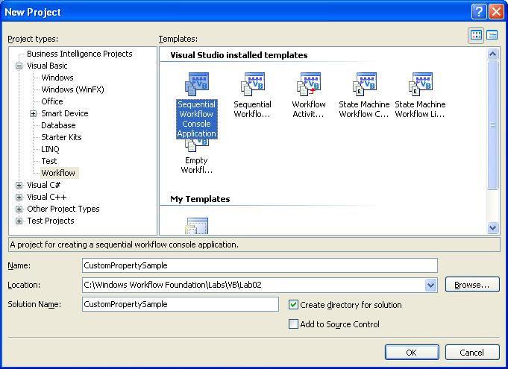

- Click OK.
- Visual Studio creates a workflow console application and opens the Visual Studio workflow designer, displaying a graphical representation of the workflow.
- Rename the Workflow1.vb workflow to SendMailWorkflow.vb by right clicking on Workflow1.vb and choosing rename.

Task 2 – Creating an Activity Project

- Select the File | New | Project menu command.
- Visual Studio displays the New Project dialog box.
- Select the Visual Basic | Workflow project type.
- Select the Workflow Activity Library template.
- Enter the name SendMailActivityLibrary in the Name field.
- Select Add to Solution from the Solution dropdown list.

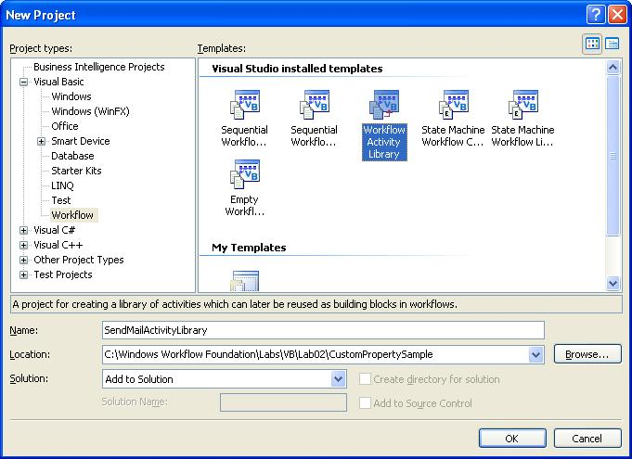

- Click OK.
- Visual Studio creates the activity library project, including a single activity, Activity1, and displays a graphical design view of Activity1.
- Rename Activity1.vb to SendMailActivity.vb by right clicking on Activity1.vb and choosing rename.

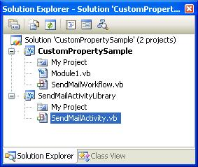
- Click on SendMailActivity title just above the “Drop Activities Here” work area to view the properties for SendMailActivity in the Properties window.

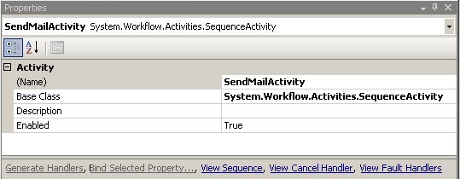

- In the Properties window, select the Base Class property.
- Click the “…” button associated with the Base Class property.
- The “Browse and Select a .NET Type” dialog box appears to allow you to select a base class for this activity.

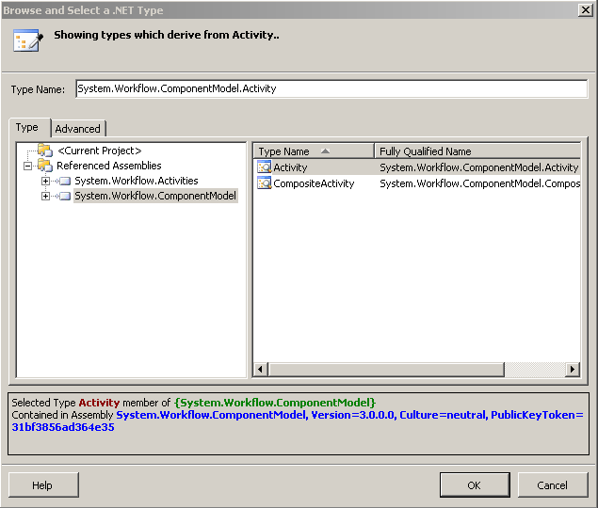

- In the Type tab, select System.Workflow.ComponentModel.
- The list box will be updated to display the two available base classes under the System.Workflow.ComponentModel namespace: Activity and Composite Activity.
- Select Activity.
- Click OK.
- In the Solution Explorer, right click on SendMailActivity.vb to bring up the context menu.
- Select View Code.
- Place the cursor on the End Sub of the SendMailActivity constructor and press Enter Twice.
- Right Click on the last line you just inserted.
- Select Insert Snippet.

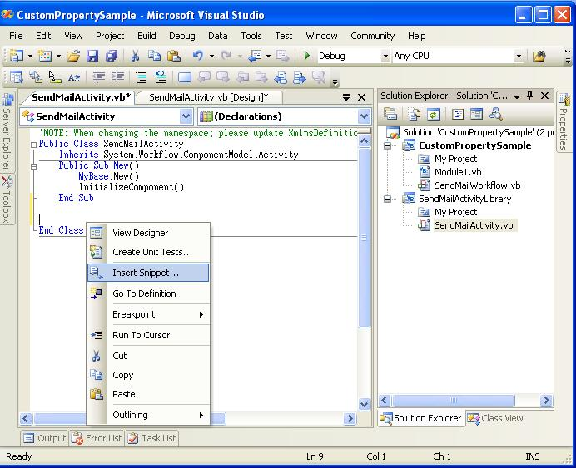
- Select Workflow.

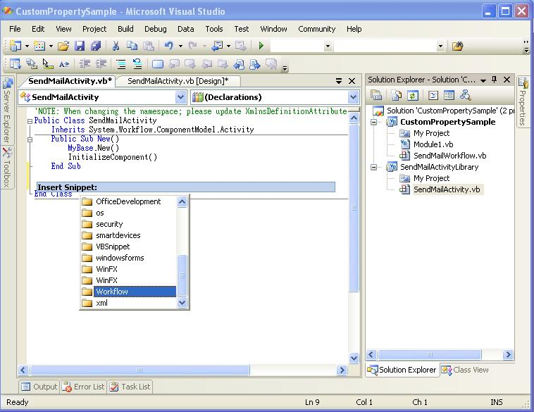

- Select DependencyProperty - Property.

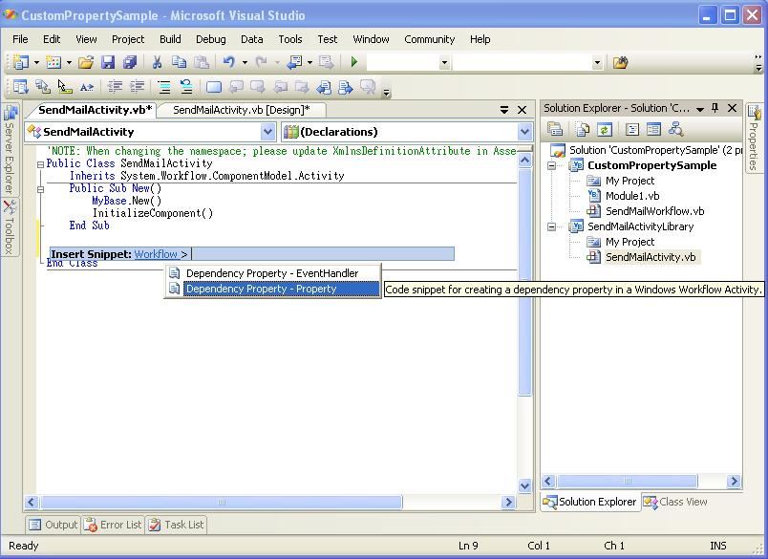
- The snippet will add some boilerplate code that we will customize below.

Here is a description of some of the attributes that can be added to the property:

Name | Type | Description
Browseable | Boolean | Indicates whether this property appears in the Properties window.
Category | String | A user-defined category for the property.
Description | String | A description for the property.
DesignerSerializationVisibility | Visible, Hidden, or Content | Determines how and if properties will be serialized.  Visible (the default) – the property will be serialized normally.  Hidden – prevents property serialization  Content – used for collection properties. The collection object itself is not serialized, however the contents of the collection are.  If a developer chooses a collection type, this property will be set to Content. If a developer chooses a non-serializable type, this property will be set to Hidden.
ValidationVisibility | Optional, Required, or Hidden | Specifies how the property’s value is validated.  Optional (the default) – the property can accept null values.  Required – The property must be set to a non-null value and is checked to ensure that this is the case.  Hidden – There is no automatic validation of the property’s value.  If ValidationVisibility is set to ‘Required,’ when the component is reused, it will require the property to be configured via smart tags, obviating the need for a check in the activity’s Validator class.

- Fill in these fields in the boilerplate code with the corresponding values. Use Tab to move between the fields and press enter when finished with the fields.
  - Name: MailTo.
  - Type: string.
  - ClassNamePlaceHolder: SendMailActivity.
  - Description: To Email Address.
  - Category: EmailActivity (this will create its own area in the property designer).

The resulting output should resemble the following.

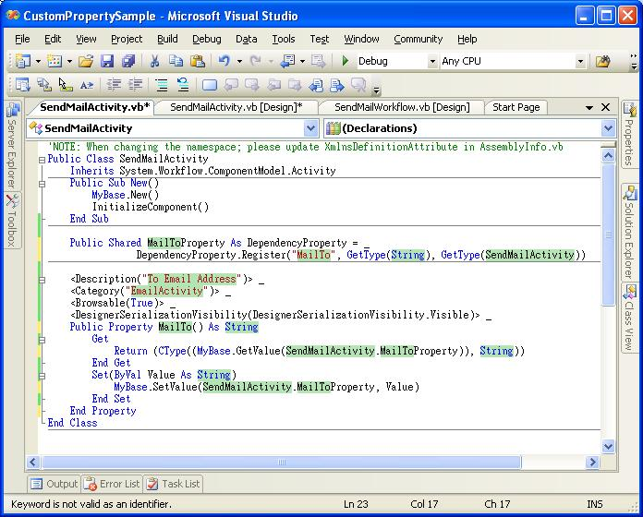

Note this code has been edited so that it will fit into the screen.

- In the same way, repeating steps 20 through 26, add the following three properties, placing the correct values for each in the appropriate fields:
Name | Type | ClassNamePlaceHolder | Description | Category
MailFrom | string | SendMailActivity | From Email Address | EmailActivity
Subject | string | SendMailActivity | Subject of Email | EmailActivity
Body | string | SendMailActivity | Body of Email | EmailActivity

The activity now has four custom properties.

Task 3 – Building the Workflow Solution

- Select the Build | Build Solution menu command.
- This step will add SendMailActivity to the Toolbox.
- Double click on SendMailWorkflow.vb in the Solution Explorer to switch to design view for the workflow.
- Notice that the SendMailActivity is now present in the Toolbox window.

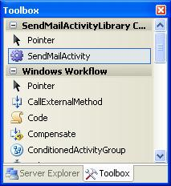

- Drag SendMailActivity from the Toolbox window and drop it onto the Visual Studio workflow designer area labelled “Drop Activities to create Sequential Workflow”. Change the (Name) property of the activity to sendMail.
- Notice that the custom properties you created previously are now available in the Properties Window for this Activity:

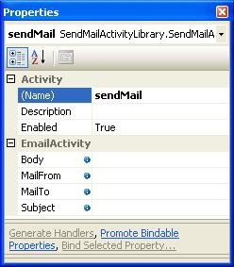

- You may now set values for the custom properties, allowing you to initialize input values for this activity in your workflow process.

Set Body to body of email

Set MailFrom to email@any.domain

Set Subject to subject of email

Set MailTo to email@some.domain

It does not matter what the format of the address at this point, as we will not be sending out an email yet. We will be using an e-mail address that is valid for the local SMTP server as we move through the lab.

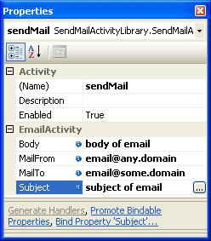

Task 4 – Adding an Executor Component

- Right click on the SendMailActivity.vb file and choose View Code.
- At the bottom of the code file, within the Activity class definition, override the Execute method on the activity. Inside this executor method, add the following code that accesses one of the custom properties of the activity and displays its contents.

(Snippet: “Lab02 Ex02 Task04 Execute”).
Protected Overrides Function Execute(ByVal executionContext As ActivityExecutionContext) _
As ActivityExecutionStatus
Console.WriteLine(MailTo)
Return ActivityExecutionStatus.Closed
End Function

Task 5 – Building the Project

- Select the Build | Rebuild Solution menu command.
- Select Debug | Start Without Debugging to run the project and see the output on the console.
- The string you entered previously for the value of the MailTo field is written to the console.

- Press the Enter key to end the program.

Task 6 – Updating the Activity to Send Email
Now that the executor has been added successfully, you will replace the line of code that prints the value of the MailTo property to the console with code that reads the properties and sends e-mail.

- First, you need to setup email on your lab machine. This lab assumes an SMTP server is set up on the lab computer as described in the readme accompanying these labs.
- Right click on the SendMailActivity.vb file and choose View Code.
- Add the following using directive to the top of the file:
Imports System.Net.Mail
- Replace the test line of code in your Execute method with the following code that uses the MailMessage and SMTPClient class to send email:

(Snippet: “Lab02 Ex02 Task06 SendMail”).
Protected Overrides Function Execute(ByVal executionContext As ActivityExecutionContext) _
As ActivityExecutionStatus
Dim toAddress As MailAddress = New MailAddress(MailTo)
Dim fromAddress As MailAddress = New MailAddress(MailFrom)

Dim addresses As MailAddressCollection = New MailAddressCollection
addresses.Add(toAddress)

Dim msg As MailMessage = New MailMessage(fromAddress, toAddress)

msg.Subject = Subject
msg.Body = Body

Dim mail As SmtpClient = New SmtpClient("localhost")

mail.Send(msg)
Return ActivityExecutionStatus.Closed
End Function
- Double click on SendMailWorkflow.vb to view its designer.
- On the sendMail Activity set the (To) property to be user@<your-machine-name> where <your-machine-name> is obtainable from the readme accompanying these labs.
- Use Windows Explorer to navigate to the directory below so we can watch for our email being delivered.

c:\inetpub\mailroot\drop
- Switch back to Microsoft Visual Studio 2005.
- Select the Build | Build Solution menu command.
- Select Debug | Start Without Debugging to run the project.
- The program will run to completion, sending e-mail using the SMTP client.
- Switch to Windows Explorer to check for your email, you should see a new file.

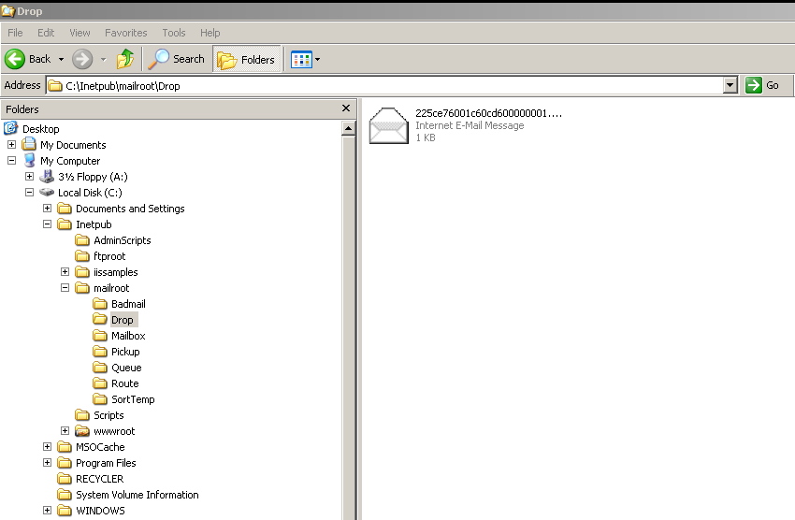

- If you have troubles with email check the log files in the directory:

c:\windows\System32\LogFiles\SMTPSVC1
- Set (To) to email@some.domain. (If you use your real email address, then you will received the email)

Exercise 3 – Adding Validation to Check E-Mail Parameters
In this exercise, you will extend the project from Exercise 2 to validate that the properties to be used to send e-mail have the correct format.

Task 1 – Adding an Email Validation Code Activity

An activity validator is a part of the Activity component model. The component model takes care of the following aspects of an activity:
- Designer: This component defines the visual representation of the activity on the workflow and custom activity designers.
- Code generator: This is an extensibility point to generate custom code for an activity in a workflow. InvokeWebService, which is an out-of-the-box activity has such an implementation.
- Validator: This component enforces the activity semantics both at the design time and run time (only during dynamic update).
- Toolbox item: Defines the custom behaviour of the toolbox item representing the activity in a design environment like Visual Studio.
- Executor: This is a stateless component which implements the execution semantics of an activity. This component may not be defined for simple cases, where the Execute() method of the activity is overridden as it was the case in the previous exercise.
- Serializer: Provides customized serialization behaviour if needed.
- Deployer: This code is run when a workflow including the activity is deployed to a hosting environment.

- In the Solution Explorer, right click on SendMailActivityLibrary project to bring up the context menu.
- Select the Add | New Item… menu item and add a “Code File” set the Name property to ParametersValidator.vb to the solution.

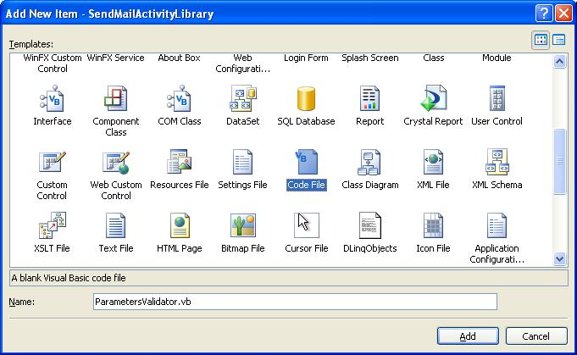

- Add the following code to the new ParametersValidator.vb file to setup appropriate inheritance relationships. An ActivityValidator class contains both design-time and run-time validation logic to ensure that an activity is appropriately configured. User-defined validation classes inherit from either ActivityValidator or CompositeActivityValidator base classes, depending upon whether your activity is a basic or composite activity. Validation occurs automatically during the compilation of a workflow and at runtime when a dynamic update of the activity is performed.

(Snippet: “Lab02 Ex03 Task01 ParametersValidator”).
Imports System
Imports System.Workflow.Activities
Imports System.Workflow.ComponentModel
Imports System.Workflow.ComponentModel.Compiler
Imports System.Text.RegularExpressions
Imports System.Net.Mail

Public Class ParametersValidator
Inherits ActivityValidator

End Class
- Override the ValidateProperties method so we can perform our custom validation on our properties. The ValidateProperties method of an activity is used primarily for verifying compile-time semantics of the properties of an activity. This validation component will check that the e-mail addresses have the correct format. Enter the following into the ParametersValidator class

(Snippet: “Lab02 Ex03 Task01 ValidateProperties”).
Public Overrides Function ValidateProperties(ByVal manager As ValidationManager, _
ByVal obj As Object) As ValidationErrorCollection

Dim validationErrors As ValidationErrorCollection = _
New ValidationErrorCollection(MyBase.ValidateProperties(manager, obj))
Dim sendMailActivityToBeValidated As SendMailActivity = CType(obj, SendMailActivity)

If IsNothing(sendMailActivityToBeValidated) Then
Throw New InvalidOperationException("Parameter obj is not of type SendMailActivity")
End If

If Not IsValidEmailAddress(sendMailActivityToBeValidated.MailTo) Then
Dim CustomActivityValidationError As ValidationError = _
New ValidationError(String.Format("'{0}' is an Invalid destination e-mail address", _
sendMailActivityToBeValidated.MailTo), 1)

validationErrors.Add(CustomActivityValidationError)
End If

If Not IsValidEmailAddress(sendMailActivityToBeValidated.MailFrom) Then
Dim CustomActivityValidationError As ValidationError = _
New ValidationError(String.Format("'{0}' is an Invalid source e-mail address", _
sendMailActivityToBeValidated.MailFrom), 1)

validationErrors.Add(CustomActivityValidationError)
End If

Return validationErrors
End Function
- You may have noticed a call to a method called IsValidEmailAddress. This is the engine of our validation, it checks the strings it is given to verify whether it is a valid email address or not. Enter the following into the ParametersValidator class

(Snippet: “Lab02 Ex03 Task01 IsValidEmailAddress”).
Public Function IsValidEmailAddress(ByVal address As String) As Boolean
' must only proceed with validation if we have data to validate
If ((address = Nothing) OrElse (address.Length = 0)) Then
Return True
End If

Dim rx As Regex = New Regex("[^A-Za-z0-9@\-_.]", RegexOptions.Compiled)
Dim matches As MatchCollection = rx.Matches(address)

If (matches.Count > 0) Then
Return False
End If

' Must have an '@' character
Dim i As Integer = address.IndexOf(Microsoft.VisualBasic.ChrW(64))

' Must be at least three chars after the @
If ((i <= 0) OrElse (i >= (address.Length - 3))) Then
Return False
End If

' Must only be one '@' character
If (address.IndexOf(Microsoft.VisualBasic.ChrW(64), (i + 1)) >= 0) Then
Return False
End If

' Find the last . in the address
Dim j As Integer = address.LastIndexOf(Microsoft.VisualBasic.ChrW(46))

' The dot can't be before or immediately after the @ char
If ((j >= 0) AndAlso (j <= (i + 1))) Then
Return False
End If

Return True
End Function
- Right click SendMailActivity.vb select View Code
- Add the following ActivityValidator attribute to the SendMailActivity, as the grey highlighted line of code shows:
<ActivityValidator(GetType(ParametersValidator))> _
Public Class SendMailActivity
Inherits System.Workflow.ComponentModel.Activity

- Select the Build | Build Solution menu command.

Task 2 – Testing The Validator

- Double click on the file SendMailWorkflow.vb in the Visual Studio solution explorer.
- Click on the SendMailActivity activity.
- Click on the MailFrom property for this activity. Enter an invalid email address.
- Notice that a red circle with a contained exclamation point appears on the activity indicating the property validation error.

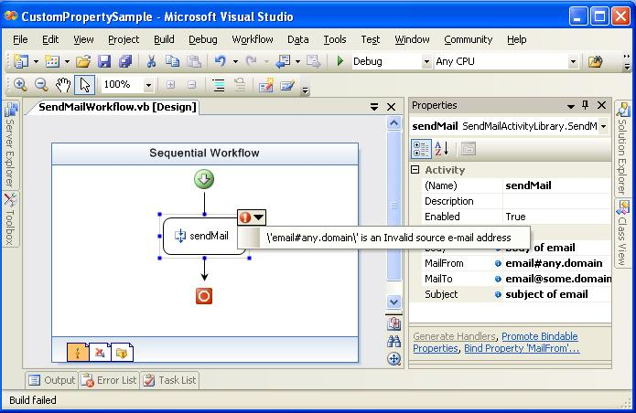

- Select the Build | Build Solution menu command.
- Notice that you will receive a compile error telling you about the invalid email address.

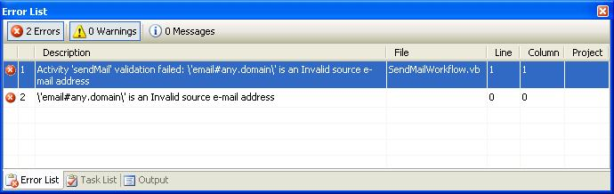

- Set MailFrom property to email@any.domain.
- Select File | Save All.

Exercise 4 – Adding an Activity Designer

In this exercise, you will enhance your SendMailActivity by create a custom design-time interface for it.

An Activity Designer defines the visual representation of the activity on the workflow and custom activity designers.

Task 1 – Add the Activity Designer

- In the Solution Explorer, right click on SendMailActivityLibrary project to bring up the context menu.
- Select the Add | New Item… menu item and add a “Code File” with the name SendMailDesigner.vb to the solution.
- Add the following code to the new SendMailDesigner.vb file.
- Paste the following into SendMailDesigner.vb to setup the SendMailDesigner class as a descendant of ActivityDesigner

(Snippet: “Lab02 Ex04 Task01 SendMailDesigner”).
Imports System
Imports System.Text
Imports System.ComponentModel
Imports System.ComponentModel.Design
Imports System.Collections
Imports System.Drawing
Imports System.Drawing.Design
Imports System.Drawing.Drawing2D

Imports System.Workflow.ComponentModel
Imports System.Workflow.ComponentModel.Compiler
Imports System.Workflow.ComponentModel.Design
Imports System.Workflow.ComponentModel.Serialization
Imports System.Workflow.Runtime
Imports System.Workflow.Activities
Imports System.Workflow.Activities.Rules

Public Class SendMailDesigner
Inherits ActivityDesigner

End Class
- We need to override three methods, Initalize, OnPaint, and OnLayoutSize, in the next steps we will detail what needs to happen and where.
- Initalize, we will override this to save a reference to the Activity that we are going to perform custom drawing upon. We also need to allow our base class to initialize also. Enter the following into the SendMailDesigner class

(Snippet: “Lab02 Ex04 Task01 Initalize”).
Dim parentActivity As SendMailActivity

Protected Overrides Sub Initialize(ByVal activity As Activity)
MyBase.Initialize(activity)
parentActivity = CType(activity, SendMailActivity)
End Sub
- OnLayoutSize, we override this to provide information regarding the size of our custom drawn object. Enter the following into the SendMailDesigner class

(Snippet: “Lab02 Ex04 Task01 OnLayoutSize”).
Protected Overrides Function OnLayoutSize(ByVal e As ActivityDesignerLayoutEventArgs) As Size
Return New Size(230, 100)
End Function
- OnPaint, we override this method in order to perform the custom drawing of our activity. Enter the following into the SendMailDesigner class

(Snippet: “Lab02 Ex04 Task01 OnPaint”).
Protected Overrides Sub OnPaint(ByVal e As ActivityDesignerPaintEventArgs)
Dim frameRect As Rectangle = New Rectangle(Me.Location.X, Me.Location.Y, _
(Me.Size.Width - 5), (Me.Size.Height - 5))
Dim shadowRect As Rectangle = New Rectangle((frameRect.X + 5), (frameRect.Y + 5), _
frameRect.Width, frameRect.Height)
Dim pageRect As Rectangle = New Rectangle((frameRect.X + 4), (frameRect.Y + 24), _
(frameRect.Width - 8), (frameRect.Height - 28))
Dim titleRect As Rectangle = New Rectangle((frameRect.X + 15), (frameRect.Y + 4), _
(frameRect.Width / 2), 20)

Dim frameBrush As Brush = New LinearGradientBrush(frameRect, Color.DarkBlue, Color.LightBlue, 45)

e.Graphics.FillPath(Brushes.LightGray, RoundedRect(shadowRect))
e.Graphics.FillPath(frameBrush, RoundedRect(frameRect))
e.Graphics.FillPath(New LinearGradientBrush(pageRect, Color.White, Color.WhiteSmoke, 45), _
RoundedRect(pageRect))
e.Graphics.DrawString(Activity.QualifiedName, New Font("Segoe UI", 9), Brushes.White, titleRect)
frameRect.Inflate(20, 20)

Dim textToDisplay As String = String.Format("To : '{0}'" & vbCrLf & "From : '{1}'" & vbCrLf _
& "Subject : '{2}'" & vbCrLf, parentActivity.MailTo, _
ParentActivity.MailFrom, parentActivity.Subject)

e.Graphics.DrawString(String.Format(textToDisplay, parentActivity.Subject), _
New Font("Segoe UI", 8), Brushes.Black, pageRect.X, (pageRect.Y + 15))
End Sub
- You may have noticed a call to RoundedRect this utility method is used to round the corners and provide a sleeker interface. Paste the following into the SendMailDesigner class

(Snippet: “Lab02 Ex04 Task01 RoundedRect”).
Private Function RoundedRect(ByVal frame As Rectangle) As GraphicsPath
Dim path As GraphicsPath = New GraphicsPath
Dim radius As Integer = 7
Dim diameter As Integer = (radius * 2)

Dim arc As Rectangle = New Rectangle(frame.Left, frame.Top, diameter, diameter)

path.AddArc(arc, 180, 90)

arc.X = (frame.Right - diameter)
path.AddArc(arc, 270, 90)

arc.Y = (frame.Bottom - diameter)
path.AddArc(arc, 0, 90)

arc.X = frame.Left
path.AddArc(arc, 90, 90)

path.CloseFigure()

Return path
End Function
- Add the following “Designer” attribute to the SendMailActivity class defined in SendMailActivity.vb, as shown in the grey highlighted line of code:
<Designer(GetType(SendMailDesigner), GetType(IDesigner))> _
<ActivityValidator(GetType(ParametersValidator))> _
Public Class SendMailActivity
Inherits System.Workflow.ComponentModel.Activity
…
- Select the Build | Build Solution menu command.

Task 2 – Testing the Activity Designer

- Double click on the file SendMailWorkflow.vb in the Visual Studio solution explorer.
- The code you just wrote to do the customized drawing will execute and the SendMailWorkflow design surface should look like this.

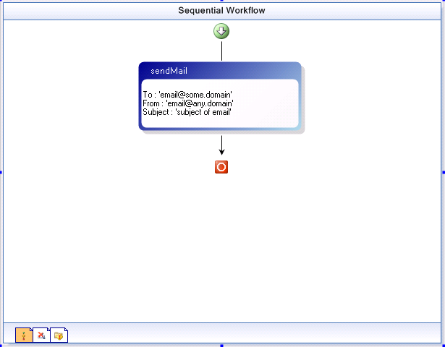

- Click on the SendMailActivity activity.
- Click on the MailFrom property for this activity. Enter an invalid email address .
- Notice that a red circle with a contained exclamation point appears on the activity indicating the property validation error, clicking on the smart tag will reveal details about the error.

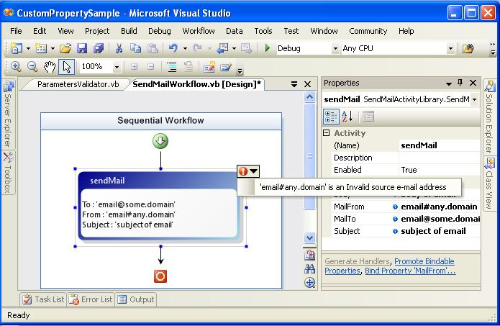

- Select the Build | Build Solution menu command.

Notice that you will receive a compile error telling you about the invalid email address.
- Set MailFrom property to email@any.domain.
- Select the File | Save All menu command.
- Select the File | Close Solution menu command.

In this exercise you used an ActivityDesigner to enhance your SendMailActivity to provide useful information on the activity for workflow developers.

Lab Summary
In this lab you learned to use Visual Studio 2005 to create a workflow that includes a composite activity. You added custom properties to the activity used to store values to be used to send e-mail. You then created an executor method for the activity that uses the custom properties to send e-mail. Then, you added validation to your activity to ensure, at design-time, that the e-mail addresses were properly formatted. Finally you enhanced your SendMailActivity project by providing a customized user interface experience.

